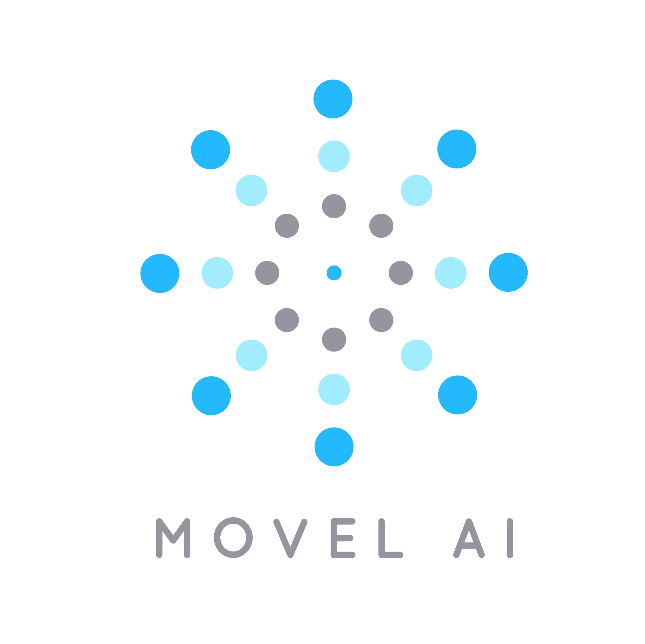

**VIT HACK 2020**



# 

# Problem Statement

To create a voice enabled robot navigation system.

# Problem Description

Participants are required to create algorithms for robot navigation based on voice recognition.

Example - The user asks the robot “*Go to the kitchen*” , then the robot needs to go to the kitchen and stop at a specific point mentioned by the user (discussed later)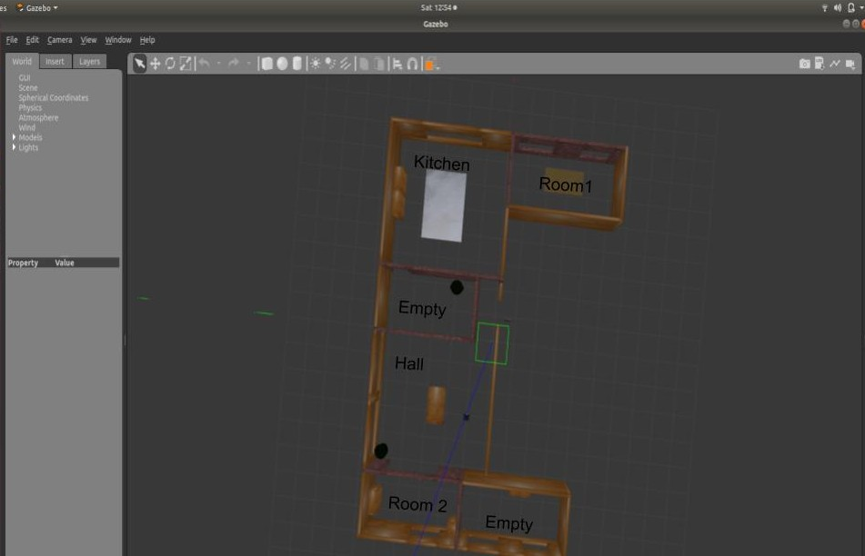

This problem will require the following points to be solved ：

1. **Environment mapping by the robot**

The robot needs to create an environment of the map.The map needs to be created so as the robot knows its location wrt the map. Eg - Whether the robot is in the kitchen or in the hall.

1. **Robot Localization**

Robot needs to know its precise location. Eg if the robot is in the kitchen, what is its location and orientation. Eg whether the robot is facing the door or the wall and how far is it from the same.

1. **Robot Navigation**

The robot should be able to go from one point to another in the map. Let us say that we want the robot to go to the hall from its present location, then the robot should be able to generate command velocities for the same.

1. **Submap(s) Creation**

You need to create submaps of every arena like rooms, kitchen, halls etc. You need to write a program where either the user can manually select points for creation of a submap or the algorithm can automatically detect the closing arenas and create submaps by itself. More points will be given to the algorithm which can automate the submap creation process. These submaps will serve as areas where the robot needs to go and stop.

1. **Voice Recognition System**

The robot should be able to understand the voice commands being given by the user. Also In the submap created, the user needs to define the point where the robot needs to go and stop. Eg if the user asks the robot to go to the kitchen, the robot should obey the command and go to the kitchen at the specific point mentioned by the user in the submap. It doesn’t need to execute any other operation.

The gist of the project lies in the voice recognition system which the robot needs to understand and subsequently, generate command velocities for navigation. If this point is not fulfilled by the participants, their project will not be considered for assessment.

# **Requirements**

OS *Ubuntu* and *Robot Operating System (ROS)*

Programming Language *C++* / *Python*

The participants will be provided with a gazebo model for the environment with a mobile robot. They will also be provided with respective packages for mapping, localization and navigation. Also a list of basic ros commands will be provided for reference

The participants can search for softwares / packages / ROS commands on the internet in case they are stuck or find any issue with the process.

# 

# Expected Output

The team is required to show the following capabilities

1. **Voice recognition capabilities** 
   1. The teams need to print what the robot has understood and what action is the robot going to take
2. **Submap created** 
   1. When the robot starts to navigate after comprehending the voice commands, the specific arena’s submap (which the robot is going to) should pop up . The stopping point in the map must be shown in red. The submap window can be closed or timed in case it interferes with the working of the rest of the process.
   2. In case the command for robot charging is set by the user, the map of the arena having the charging station should be shown but the robot needs to stop at the charging station
3. **Robot Navigation**
4. The motion of the robot should be shown on Rviz

**The team needs to make a video of their work and submit along with their codes. The audio commands given by the user should be clear and audible in the video.**

# 

# Points System

1. **Successful voice Recognition System - 100 points per command**

The robot is able to understand the commands and decipher the queries. The participants have to print on terminal what the robot has understood and where is the robot going to navigate

* 1. There are 4 commands that the robot needs to adhere to
     1. Go to the kitchen
     2. Go to room 1
     3. Go to room 2
     4. Go for charging
  2. Let us say that the user said “ go to room1” but the robot goes to room 2 or vice versa, 50 points will be awarded in this case. But if the robot was asked to go to the “kitchen” but it goes to “room 1” or “room 2“ or “hall”, this will result in 0 points being awarded.
  3. If a minimum of 200 points are scored in this section, only then the next point i.e **Successful navigation after voice recognition** would be considered.

1. **Successful navigation after voice recognition - 100 points per command**

Successful navigation would mean going to the specific point that the user has mentioned after/during the voice recognition section. If the navigation is completed successfully, 100 points will be awarded. If the robot navigates to the correct arena but stops away from the stopping point, like more than 100cm away, 50 points will be awarded.

1. **Creation of submaps - 100 / 50 / 0 points** 
   1. If the algorithm automatically creates submaps, the team will be awarded 100 points
   2. If the team decided to write a code for manual selection of points for submap creation, 50 points will be awarded
   3. If no sub maps are created and the navigation is done on the main map i.e the map created of the environment, no points will be given to the teams for this section but the project will be considered for assessment.